# Question 13.2

*In this problem you, can simulate a simplified airport security system at a busy airport. Passengers arrive according to a Poisson distribution with λ1 = 5 per minute (i.e., mean interarrival rate µ1 = 0.2 minutes) to the ID/boarding-pass check queue, where there are several servers who each have exponential service time with mean rate µ2 = 0.75 minutes. [Hint: model them as one block that has more than one resource.] After that, the passengers are assigned to the shortest of the several personal-check queues, where they go through the personal scanner (time is uniformly distributed between 0.5 minutes and 1 minute).*

For this question, I used the arena software to create a simplified airport security system. As instructed, I created both the ID/Boarding-Pass Check Queue (*µ1 = 0.2 minutes)* and the personal-check queues *(uniformly distributed between 0.5 minutes and 1 minute).*

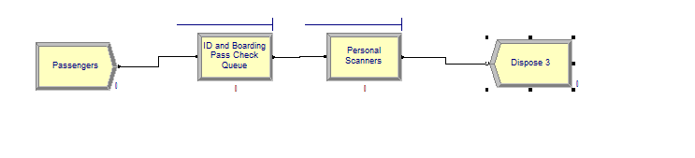

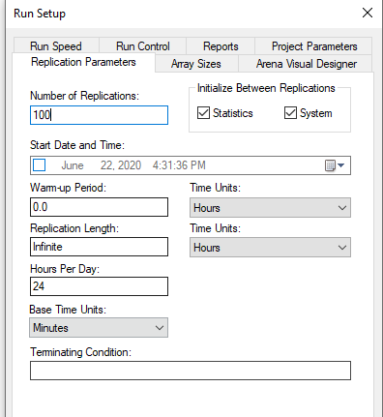After running various versions with different combinations of resources for sets of queues, I found that a combination of 3 ID/Boarding Pass Check Queues and 4 Personal Scanners kept the wait time below 15 minutes and used a total of 7 resources. In a real-life setting, an important question would be to ask how much the operation and initial cost would be for a marginal queue of each type and determine the trade off between waiting and cost. For example, if the person scanner costs twice or three times as much as the ID and Boarding Pass Check both to operate and to order initially (which actually sounds plausible), then a better combination would be to use 4 ID and Boarding Pass Queues and 3 Personal Scanner Queues since the average waiting times for both combinations (4-3, and 3-4) are quite similar. So, it would be cheaper to opt for the 4-3 option since it is more cost effective.

I ran the simulations with the following set up *(displayed on the right).*

**Results**

These were the results of the average waiting times for three combinations that seemed most promising.

3 ID and Boarding Pass Queues, 3 Personal Scanners

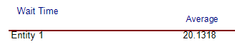

4 ID and Boarding Pass Queues, 3 Personal Scanners

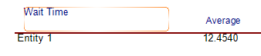

3 ID and Boarding Pass Queues, 4 Personal Scanners

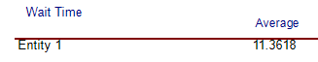

**Conclusion**

As we do not have any idea about what the operating costs are of each queue type and we are just trying to reduce the total number of resources, the best way to keep it under 15 minutes average time is with 3 ID and Boarding Pass Queues and 4 Personal Scanners. Please see final Arena report if you want to see full results. Thanks.